Practical 7
Aim : Session Impersonation with Firefox and Tamper Data
- Install and configure the Tamper Data add-on in Firefox.
- Intercept and modify HTTP requests to impersonate a user's session.
- Understand the impact of session impersonation and the importance of session management.

Step 1: Install and open Firefox browser. Go to https://addons.mozilla.org/enUS/firefox/ i.e. Firefox Browser ADD-ONS and search for Tamper data. Add that extension to the browser. Similarly search for Cookie Editor and add that extension too
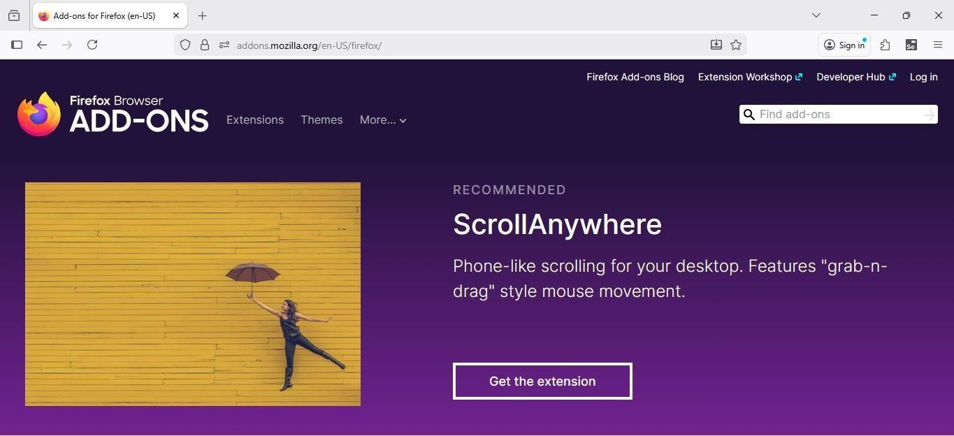
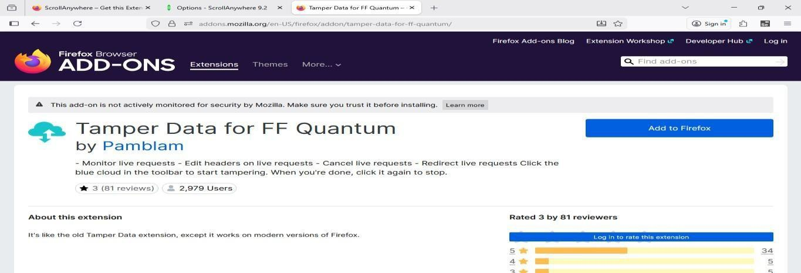
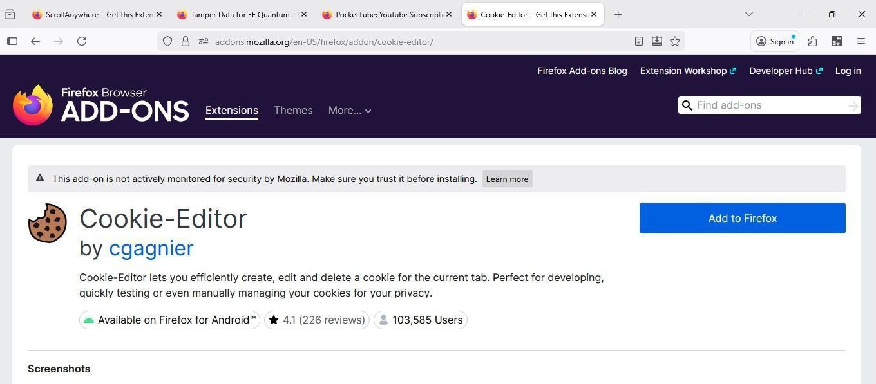

Step 2: Go to https://www.techpanda.org/ and enter the email id and password as follow:
Email id: admin@google.com Password: Password2010
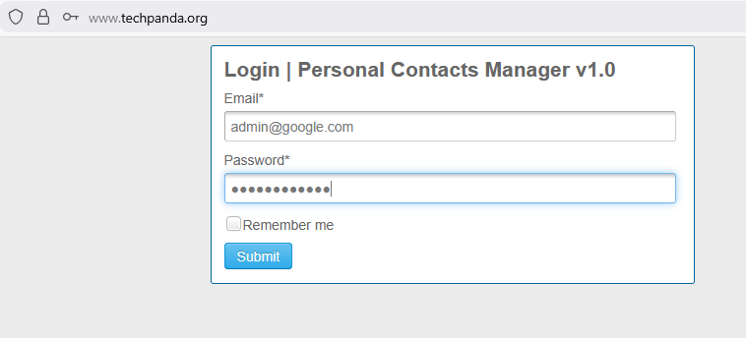
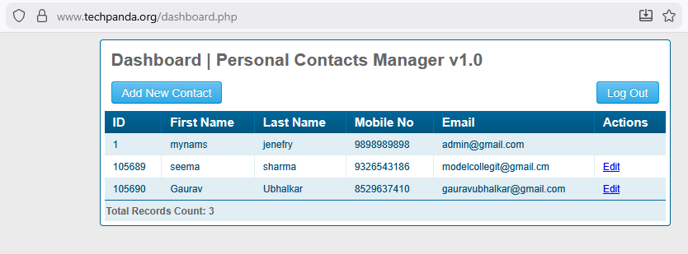

Step 3: Click on Cookie-Editor Add-on and copy the session id as shown in the below image.
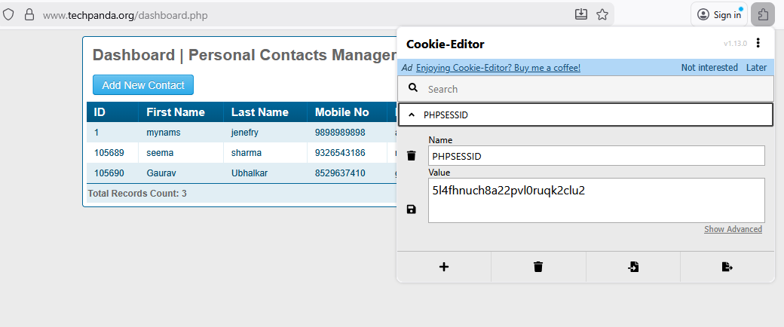
Step 4: Go to Settings and select Privacy & Security option from the left tab. Scroll down to the Cookies and Site data and click on Clear Data button to delete the cookies

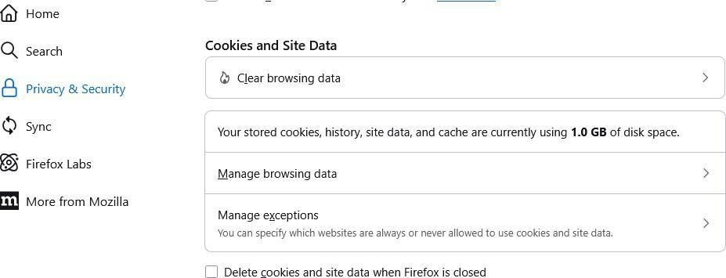
Step 5: Click on Tamper Data Add-on which will prompt you with the following window. Click on
Yes button.
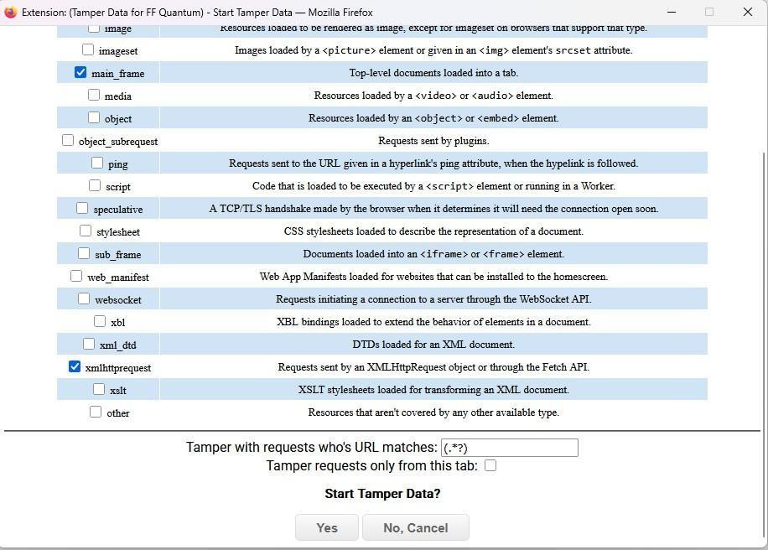

Step 6: Go to https://www.techpanda.org/. The following window will be prompted if you navigate to any web search.
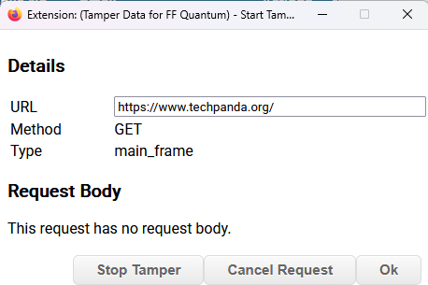

Step 7: Go to https://www.techpanda.org/index.php and click on Ok button. In the Cookie Header (Click on Add Header option and add the Cookie Header if it isn’t already present), paste the copied session id (Ex: PHPSESSID=your_session_id). Click on Ok button.
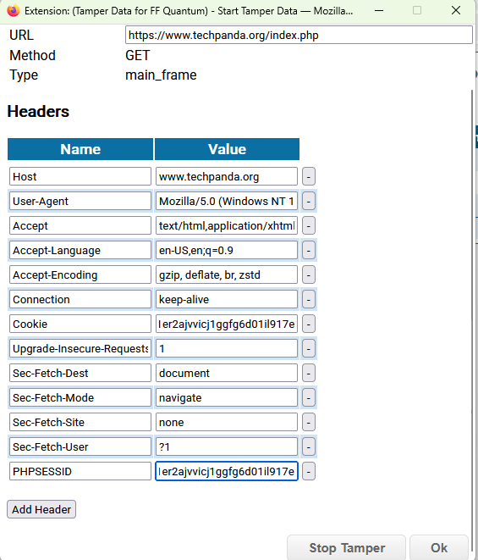
Step 8: In the dashboard.php page, click on Ok button. Paste the copied session id in the Cookie header just like in the previous step
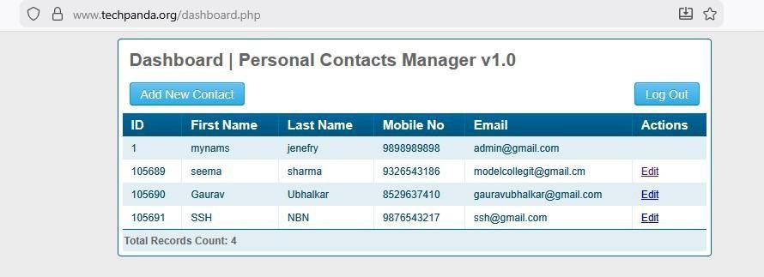
Step 9: You will be logged into the dashboard page directly without even entering the login credentials.

